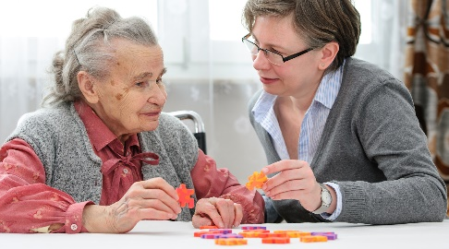
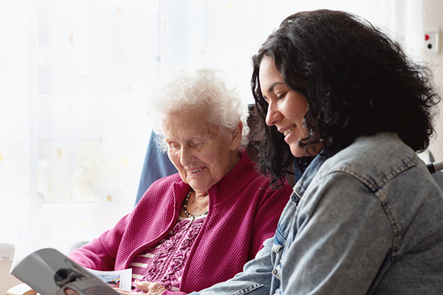
The majority (80%) of people with Alzheimer’s disease and related dementias are receiving care
State Government

The state government should provide resources such as funds and design the implementation process for identifying and disseminating the grants.
Discuss the presented bill in detail to come up with solutions to the various issues emanating from the motion. Much considerations should be on safety of the patients.
Senate and State Legislators

Nursing Researchers
Conducting research and collecting enough data for supportive evidence in approving the importance of providing caregivers with the grants.
- Stress for the caregivers (61%)
- Depression for Caregivers (39%)
- Violence against the patients
- Unsafe practices
- Delayed clinical and health care for the patient.

Should push and campaign for the implementation of the policy through the political systems.
State Nursing Associations

Key Stakeholders
- Unpaid caregivers for dementia patients are not trained on handling dementia patients and thus need adequate skills to improve their understanding on basics of care.
- Dementia and Alzheimer’s disease patients are difficult to handle and these requires higher level of understanding among the caregivers.
- Caregivers for dementia patients spend much time with the patients and thus have less time for their economic support activities. Providing grants for the unpaid caregivers enhance the support for basic financial needs that support both the caregiver and the patient.
- Appreciative support is motivational to reduce depression and other social factors that may hinder quality of care or safety of the patients.

- Over 80% of patients with Alzheimer’s Disease receive care
- More than 16 million Americans providing unpaid care for the Alzheimer’s disease and dementia patients.
- In a year, the unpaid caregivers provide about 18.5 billion hours of care, indicating their vital contribution to improving their health.
- About 2/3 of the dementia patients are women with 34% being the elderly population aged 65 years and above.
- About 25% of the caregivers are “sandwich” population, indicating that they take care of the aged and the children.
- Alzheimer’s caregivers spend more time with their patients over caregivers for other health conditions (79% compared to 66%).
- About 63% of the Alzheimer’s patients require care for more than 5 years.

Statistics of Alzheimer’s Caregiving in the USA
References
Brown, J. (2020). The Impact of Alzheimer’s on Caregivers (infographic). ActivCare® Living. https://activcareliving.com/caregivers/alzheimers-caregivers-info/
CDC. (2019). Caregiving for Person with Alzheimer’s disease or a related Dementia | Alzheimer’s disease and Healthy Aging | CDC. Centers for Disease Control and Prevention. https://www.cdc.gov/aging/caregiving/alzheimer.htm
Seidel, D., & Thyrian, J. R. (2019). The burden of caring for people with dementia–comparing family caregivers and professional caregivers. A descriptive study. Journal of multidisciplinary healthcare, 12, 655.

Impact of Unprofessional Caregiving
Reasons for Alzheimer’s Caregiving Grants in the USA
GRANTS FOR UNPAID CAREGIVERS FOR ALZHEIMER’S DISEASE PATIENTS?

H.R. 1474: Alzheimer’s Caregiver Support Act
This bill “authorizes grants to expand training and support services for families and caregivers of individuals living with Alzheimer's disease or a related dementia. The Department of Health and Human Services may award these grants to community organizations and health care and social service providers.”

